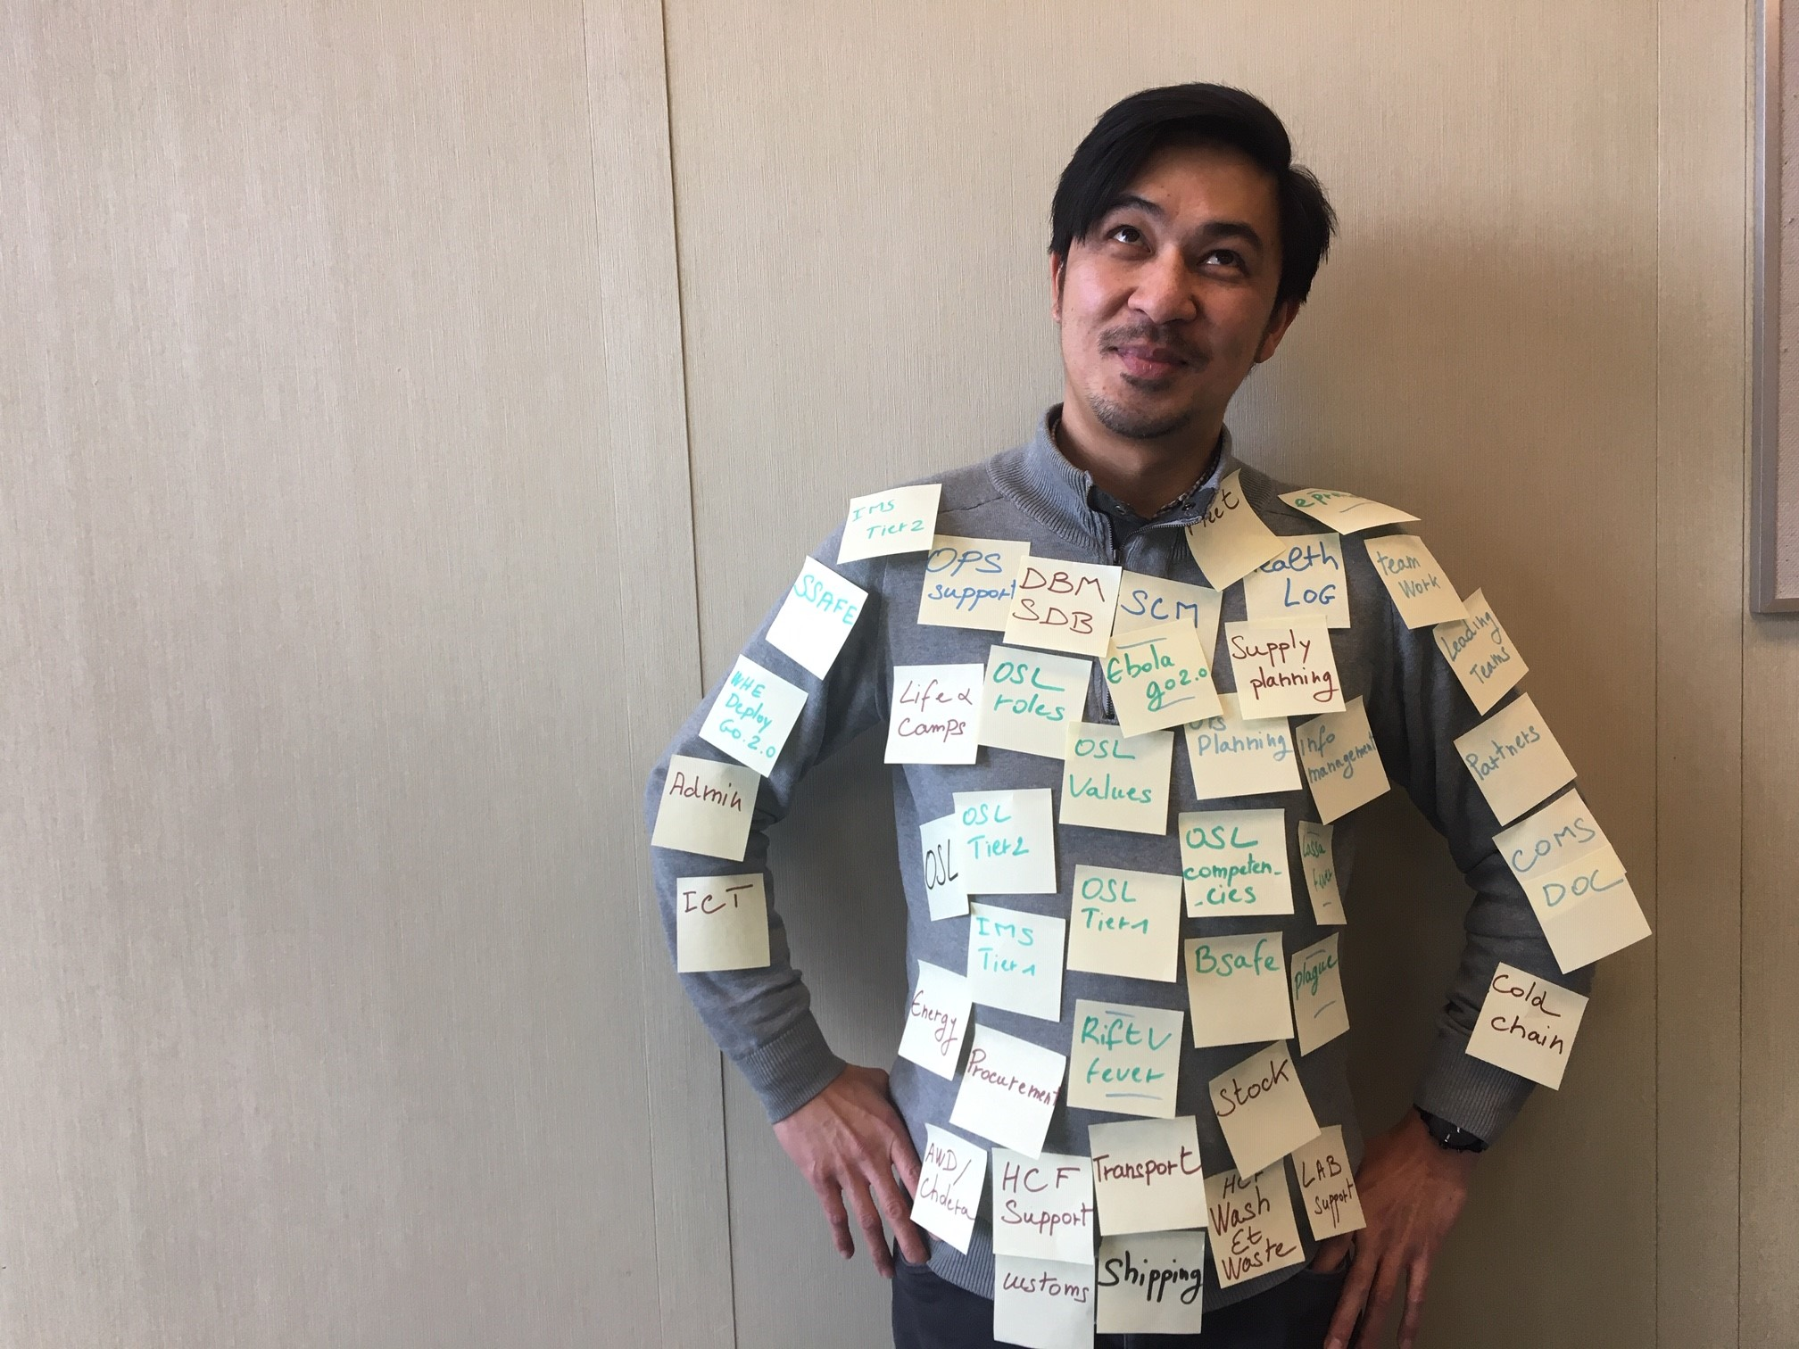
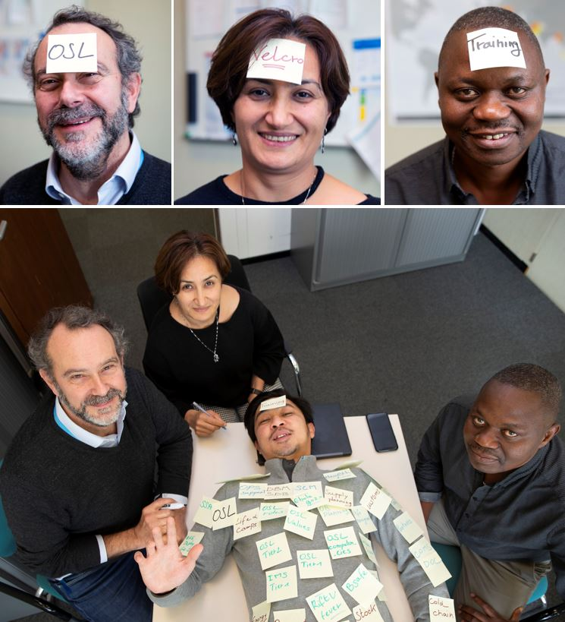
The art of making the Learning Stick!

Everything you ever needed to know about OSL Velcro Training

Operation Support & Logistics Trainings Development Toolbox

This compodium is a living document made to help emergency OSL personnel develop training & learning materials using templates and best practices TO maximize the QUALITY AND impact of trainings.

Rev 1.2 – 30MAR2020

Content

Introduction 4
1. Simple Steps to Training Success 5
2. OSL Global Master Trainer (GMT) Support Hotline 7
3. Training Needs Analysis (TNA) 8
3. Training Curriculum Template 8
4. Functional Training Agenda 9
5. Session Plans Templates 9
6. Power Point Presentation Template and Guidelines 10
7. Monitoring, Evaluation & Improvement 10
8. Competency Assessment 12
Annex A: Training Needs Analysis Template 14
Annex B: Training Curriculum Template 23
Annex C: Training Session Plan Template 27
Annex D: Training Review/Feedback Template 36
Annex E: Trainer/facilitator Self Review Template 37
Annex F: Competency Assessment Template 39

Introduction

Quality training design and delivery follow standards to make learning sticks and worth the investment. This simple manual offers a tool kit to design, develop and deliver training that will meet those quality standards and best practices for adult learning.
It is designed for facilitators who are planning, managing, and/or delivering training, or all the above combined. The manual is based on simple tools, tips and techniques collated from training and learnings experts in WHO and in partners agencies.
It is informed by the WHE Learning Strategy and the OSL Learning pathways to achieve OSL Foundational, Technical, Functional and Leadership training objectives.
The key tools are included either as Annexures to the document or as links within the document following of the training development process described below.

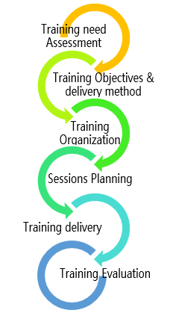
TRAINING NEEDS ANALYSIS TEMPLATE – Annex A

TRAINING CURRICULUM TEMPLATE – Annex B

FUNCTIONAL TRAINING AGENDA – LINK

SESSION PLAN TEMPLATE – Annex C

POWER POINT TEMPLATES & GUIDE – LINK

COMPETENCY ASSESSMENT TEMPLATE – Annex F

TRAINING REVIEW TEMPLATE – Annex D

FACILITATION REVIEW– Annex E

1. Simple Steps to Training Success

Before you even think about developing a training, there are some vital aspects to incorporate in the design and plan of the workshop/course which reflect best practice and principles of adult learning.
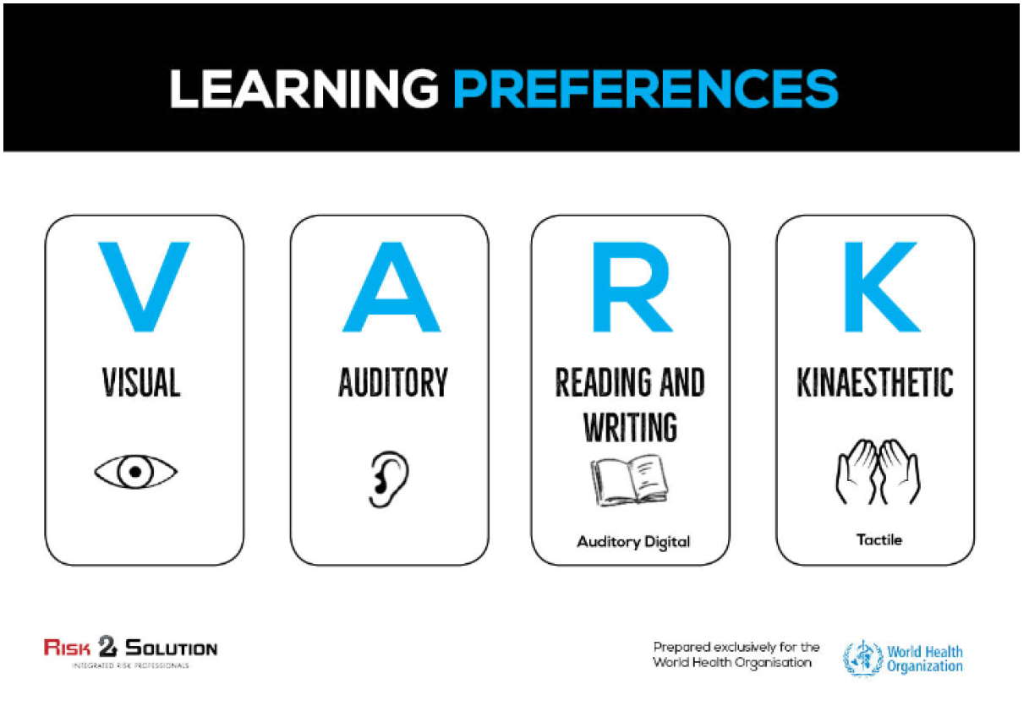
These principles must be incorporated in your various means of delivery of the training.

For example, using visual, auditory, reading & writing and kinaesthetic means (hands-on) of interaction with the participants – such as Q&As, story/experience telling, posters that reinforce specific teaching points, flash drives with resource materials, and adequate time for reflection and to do & practice, to provide the most appropriate environment for learning.

As the course designer, use the training agenda (§3) as a “gross error” checking tool to make sure that there has been adequate consideration of these concepts.
You should now watch the video on Adult Learning Principles and tools at:
https://www.dropbox.com/s/hkk2f18u6hsbldu/WHO%20Adult%20Learning%20Final.mp4?dl=0
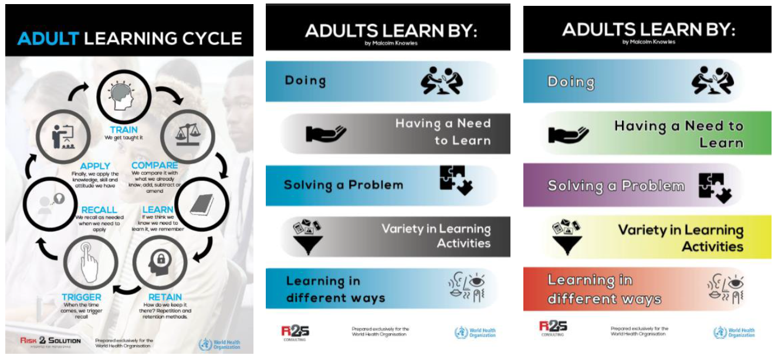

We have also created these posters to help you and others remember the key concepts under what is called quality adult learning methods.
Link to posters and other visual helps is at : https://www.dropbox.com/sh/znf0of6euishwb3/AABPYCHLzEcPMph5jpzSMRrva?dl=0
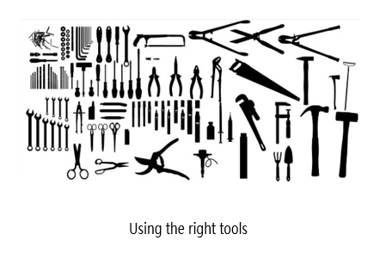
You will see that that an important part of a Learning Programme is the development of a common learning theme. As an example, in the example agenda attached below, we have used the concept of “Toolbox”.

In the recent OSL leadership training in Dakar this was reinforced with an actual “Toolbox” provided on the participant tables; the consistent reference to the use of OSL “Tools”; the idea of reminding participants to consider carefully in reflection activities – what tools did they use, what did they wish they had used’; what was not used well; and what tool do they wish know more about etc. This can be facilitated or just tasked as in “write on a post it notes…. and put in the toolbox, the tool you used the most in that activity” etc.
The theme of “toolbox” is not specifically relevant to the design and planning process; it is the concept of a binding theme throughout that is both relevant and important.
Other frequently used themes are “going on a journey”; “building a house or a boat” etc. All are useful in tying the story together in a way that helps make the learning stick!

2. OSL Global Master Trainer (GMT) Support Hotline

You are not alone. Because developing a training without all tools or the experience might be at time intimidating, WHE OSL has established an online global master trainer support hotline. This manual and the support of the GMT will provide you with all the tools and resources you need apart from your own great skills and experience, to develop a sound, adult friendly course, designed to make the learning stick, for long term impact.

You can call using Whatsapp on + 61 411248505 or email on leonie.b@risk2solution.com.

You will get a response within 24 hours, and often faster – if you are nice . Support is available from the GMT in the form of coaching and mentoring, telecom advisory services, drafting and editing of documents and basic advice in experiential training. The general form of response and support will be face to face via zoom online, so it is best that you have access to a computer with camera and audio support.




WHATSAPP LEONIE – SHE IS GLAD TO ANSWER YOUR TRAINING QUESTIONS

3. Training Needs Analysis (TNA)

It is important that whatever training is conducted, a simple Training Needs Analysis (TNA) process is followed. See Annex A to look at the template and a detailed description of how to complete it.
The TNA is where you think about the training needs;
- in context of the participants and the of client (Stakeholders),
- about how the training might be delivered (Delivery Model),
- and about different training techniques that might be used (Delivery Techniques).
You may choose not to complete every box, but it is a useful way of thinking about the context of the training you are preparing to deliver.

3. Training Curriculum Template

A bit of Math. Training Needs Analysis + Training Curriculum = Learning Programme
Once you have identified the need, the stakeholders, the model for delivery, and the methods, you can then pull all of that together into a learning programme plan.
The best way to do that is to develop a Training Curriculum see Annex B. This is a tool for designing and developing a learning program and the example is based on an actual three-day Introduction to a Monitoring and Evaluation learning programme that was implemented in Papua New Guinea.
Once this very basic learning programme is developed, then it is supported by a more detailed Functional Training Agenda which is outlined further below in the document in the link below.
The Training Curriculum Template outlines each component of the program, so a clear breakdown can be seen. It may be set against a timeline or it may show a series of sessions that make up the wider program. The plan outline will clearly show:
- The competencies or other benchmarks to be achieved to be chosen from the OSL Competency Framework (in the OSL learning and development Strategy and/or the WHE or WHO Competency frameworks).
- The specific learning outcomes for each session (at the end of this session participants will know how to …)
Having a learning programme gives clear guidance to everyone and allows the bigger picture to be formed, which then supports development of session plans and selection of resources to support the curriculum.
This then leads to the simple secrets of training success, or “Velcro Training - the art of making learning stick”.

4. Functional Training Agenda

The best way to develop the detailed course curriculum after working through the TNA and the curriculum template is to use the functional training agenda template as provided in excel format below. Click on the icon below to go to the example.
At the start of the design of the training, this matrix allows the course manager to decide with the clients and facilitators which eLearning requirements, session plans, PowerPoint presentations, activities and resources are to be used.
The spreadsheet can then be used as a project management tool between the stakeholders which easily translates to tasks and dates. It can be shared on a sharepoint site, or a google drive, dropbox etc.
Once the overall format of the training has been discussed and agreed, then facilitators can be tasked to further develop the individual Session Plans and accompanying PowerPoint presentations and activities best suited to the audience and location of the course.
Much of this will have been decided in the TNA process at the very beginning (§3).

5. Session Plans Templates

Ideally there should be a Session Plan and a set of Power Point slides and resources for each Session highlighted in each module of the Learning Curriculum.
The Annex C gives an example of a detailed session for communicating in Emergencies there is no attending PowerPoint slide presentation.
The session was designed to be delivered in a very experiential manner, using interactive methods, and no slides.
Remember that resources described in the session plan should be reflected in the excel matrix of the functional Training agenda – because it’s more convenient if you have to glance at all the resources needed and shared with others.
Another example below presents a session plans for an OSL introduction during an IMS Leadership Training scheduled in EMRO in 2019.

The draft Presentations associated are also copied below as examples.

6. Power Point Presentation Template and Guidelines

Select the links below to check examples for PowerPoint templates and to get tips on best practice for development of PowerPoints. This PPT contains also OSL Icons for dashboards and are available in WIDE 16:9 size and Standard Size 4:3.

An example of presentation following these guidelines, describing what is an OSL Learning Package is available below.

7. Monitoring, Evaluation & Improvement

There are four basic levels of training evaluation. These are identified by Kirkpatrick as Reactions, Learning, Behaviour and Results (or Impact). In direct training, we can only ever measure the participants reaction and learning at the time. At the Reactions level, we ask how participants felt about the workshop, often described as did they like the course, the people, and as people often joke “how was the quality of the lunch and snacks provided”. Generally, though, this first level assesses the effectiveness of the workshop and provides input that can improve future trainings. At this level, both the facilitator and participants are given an opportunity to provide feedback on the quality of the facilitators, training activities, training environment, and training content. One concise way to think about workshop evaluation is that is should evaluate based on a logical flow from what happened to what should happen next time.
Evaluation Methods that could be used include: Group discussion, questionnaire, open-form evaluation sheets collected at the close of the workshop.
A standard Peer Review/participants Training Template Form is available in Annex D. A self-assessment for Facilitator/trainer is in Annex E.
At the Learning level we confirm the individual knowledge and skills that participants retain from the training. Several methods exist to measure the retention of knowledge and persistence of impact that we will share at a later stage, when you are familiarized with this toolkit.
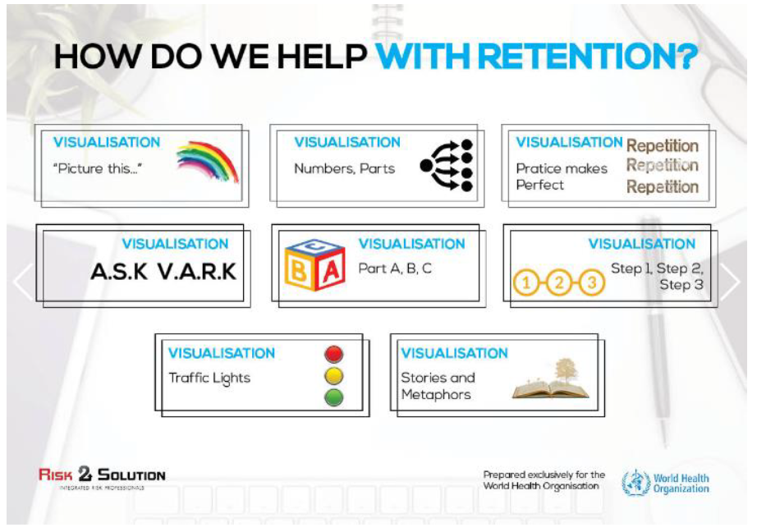
Simple Evaluation of retention of knowledge methods that could be used include: Group discussion, formal questionnaire, pre and post testing, Competency Assessments, self-reporting.

8. Competency Assessment

The major competencies OSL is looking to develop are teamwork, communications, moving forward in a changing environment, applying technical expertise; and building and maintaining partnerships. These are normative assessments and should be assessed as competent or not yet competent, with guidance provided on areas for improvement to reach standards.
Competency Assessment tools should measure through a triangulated approach a participant’s capacity to achieve a certain standard of competency in given areas which have been mapped as critical to a behaviour or particular skillset. Competency can be measured through by direct observation, questioning, simulation or the production of a portfolio of evidence (which includes the recognition of prior learning).

OSL has developed a specific competency framework from the Existing WHO Competency model to help describe expected behaviours, skills and experience relevant to OSL functions from the officer level to the team leader.
These competencies are described in detail in OSL Learning and Development Strategy – To be released by the end of 2019.
A simple template for competency evaluation during a training is available below.

A Description of the Competency Assessment Template is provided at Annex F.

Annex A: Training Needs Analysis Template

Training Needs Analysis
Sit down with your “client” and ask questions that allow you to find out the who, what, where, when, how, and why of the training needs. You need to understand your potential students and consider their learner profiles.
See the sample template below that can be useful to fill in and review in terms of coming up with a Learning Programme. Getting this first step right and recording the information in a systematic manner is important. Following this, you can then start to make decisions about how you can present information and guide the learning process to make the learning stick.
For example, let’s use this scenario.
Geoff is from WHO Regional Office and has been asked to go to a country supported by the WRO to provide training to the government health services about roll out of logistic support in incident crisis management – e.g., response to Ebola, Avian Flu etc. The Team leader there feels that the team of 20 staff he must work with there have great enthusiasm and energy but lack some basic business skills required to roll out the programme throughout the island. He considers doing some training in business for his staff. His staff is made up of both government and non-government staff as well as some dedicated community volunteers. Geoff uses the template to work through the training needs and gap analysis.
Training Suggestion

Part 1.  Overview of Client Needs | Industry/Organisation operation | Details – description of operation.
Part 1.  Overview of Client Needs | Need not currently met – skills and knowledge required | Meet with all and discuss needs and gaps.
Part 1.  Overview of Client Needs | Generic work skills and competency skills that are needed | Understanding of the relationship between training package and workplace.
Part 1.  Overview of Client Needs | Client priorities | What is it exactly that the client wants from this training
Part 1.  Overview of Client Needs | Target learner group | How many students. Detail to include understanding of subtle characteristics including any ethical considerations, age, gender, language, literacy and numeracy issues
Part 1.  Overview of Client Needs | Other stakeholders? | Understanding of bigger picture and relationship of all parties.  Identifying specific people relevant to the competency.
Part 1.  Overview of Client Needs | Suitable timeframe | Is this a once off training? Is it scaffolded in other training? How long will be needed?
Part 2. Qualifications Framework:  Foundational  Technical  Functional  Leadership | Source of training Package information | Describe the structure of the training package that this request might be related to – sources of training package information.  Accredited courses.  Other community options – codes of conduct, Sphere Standards, etc.
 | Name of training package chosen | Technical etc
 | Course Name/Title | Introduction to XXX
 | Reasons for above | Linking organisation-specific terminology to the competency.  How is the learning need linked to this particular qualification and/or learning content?
 | Mode of learning | Face to face. Demonstration of cognitive skills to analyse, interpret, and apply the various components and relate to workplace needs.
 | Pathways to and from the qualification | Details of the course and how it fits in the learning pathway
Part 3.  Training Package Details – Insert assumptions, risks, opportunities | Qualification rules summation – key features
 | Recommended electives or skill set details and governing rules | Format and structure of the course you are proposing to meet the needs
 | Suggested support materials? | Online courses?  Workshops?  Resource material?
Part 4.  Contextualisation and Application within Organisation | Justify the link between the chosen modules/subjects/courses and explain how they meet the client needs | 1.  2.  3.  4.
 | Sequencing and/or clustering of particular units | What should be done and when?
 | Dimensions of competency – notes on:  - Communication  - Teamwork  - Moving forward in difficult environments  - Partnership  - Technical Competence  - Other | This detailed understanding of dimensions of competency and how used:  WHE and WHO Competency Frameworks
 | Contextualisation details? | Detail – understanding of parts of a generic training package that can be contextualised and how  specific tools and equipment might be adjusted to the needs
 | Licensing and prerequisites? | Specific details required?
 | WHO OSL Learning Strategy | How does this need fit into the WHO OSL Learning Strategy – role & function within the IMS role and WHE OSL position
 | Organisational quality assurance policies and procedures | Identifying policies, procedures, processes, and forms relevant to the competencies.
 | Further stakeholder consultation required? | Understanding of organisation and stakeholders.
Part 5.  Assessment Guidance | Application of assessment to enterprise – RPL | Outline how assessment will work in conjunction with the team; offer a recognition of prior learning if needed.
Part 5.  Assessment Guidance | Mandatory assessment requirements | Clarification of assessment guidelines and critical components.  Direct Observation  Questioning  Simulation  Portfolio of Evidence
Part 5.  Assessment Guidance | Special requirements/reasonable adjustment to be recommended | Identifying specific people who have special needs and recommend approach.

Stakeholders

Target Group
There are many ways to find out about a target group of learners. It may be through information received from employers, company files, or discussions with supervisors or the individuals themselves. Observation of learners in the workplace is another method of gathering data. At times, speaking directly with them can develop a more accurate picture of the learners.
You should consider:
- Level and breadth of work experience
- Level of previous experiences of formal education
- Existing skill or competency profile
- Socioeconomic background, age, gender, range of abilities
- Cultural background and needs
- Special needs – physical or psychological
- Motivation for learning
- Language, literacy, and numeracy needs of learners
- Learning style and preferences

Resources
Now you can start to consider resources — both existing and those to be developed. Most organisations or industries have good training records already. Make sure you investigate carefully what has already been developed and then adapt them. Consider previously prepared curriculum (learning programmes) and session plans, case studies and scenarios, YouTube and Google (online resources), DVD AND libraries, etc.
Use the checklist below to assist in reviewing the quality of the resource:
- Is the resource current?
- Does the resource cover the competency standards or learning outcomes that need to be addressed?
- Does the resource provide clear and comprehensive information?
- Does the resource clearly identify its purpose?
- Is the resource able to be contextualised to meet the learners’ needs?
- Does the resource respond to access and equity issues?
- Does the resource offer flexibility for delivery and assessment?
- Is the resource recognised by registration or accrediting bodies?

Selection of training aids?
- Learning Outcome – Will the training aids help you fulfil the learning objectives?
- Location of training area (inside, outside) – This may make it difficult to have privacy, use some training aids, and perhaps have access to electricity.
- Session content – Combinations to reflect learning styles.
- Costs – How much will the training aids cost to use?

Copyright?
Copyright applies to all published material whether written, in audio or video form, or computer based. Http://www.copyright.org.au/find-an-answer/ is a great website to find answers about copyright. There is a concept called fair use, and that is very relevant to trainers. You should be familiar with this. Regarding the copyright of materials, the first step is to consult the publisher or the Australian Copyright Council Ltd. at www.copyright.org.au.

Delivery Models
It is up to the trainer and the client to discuss the best model of delivery of the learning programme. This could be conducted online, face-to-face, in the workshop, in the field, by correspondence, over a long period of time, short intensives, etc. Anything goes really, but there are some pros and cons around whichever selection is made. In the community context, it is even more important to consider delivery, especially in terms of existing language, literacy, and numeracy requirements of the client, both the learner and the management group you may be working with. Issues of translation need to be carefully considered, as well as some forms of delivery which might lend themselves better to this part.
Model | Advantages | Limitations
Off-the-job  Participants are grouped and attend regularly. The trainer moderates learning pace, sequence, and methods. | - Familiar to all  - Provides interaction and social opportunities between participants  - Adjustments can be made continually | - Whole group needs to meet  - Usually, course delivery pace set by trainer  - Structured time allocation  - Time and place dependent  - Inaccessible to distant potential participants
On-the-job  Training in the workplace. | - Provides interaction and problem-solving opportunities  - Peer support in real workplace situations | - May impinge on workplace activities  - Time allocation of peers or mentor
Distance learning  Participants use resource packages to learn off-campus. | - Cheaper to administer  - Easy to transport  - Encourages independent learning  - No technical skills required  - Can stand alone | - High degree of self-direction and motivation needed  - High degree of literacy required  - Mail and return times may slow down process
Online  Participants use e-mail and the Internet to access resources and information | - Participation in the learning process for people who would otherwise be unable to access this training  - Enables familiarisation and practice with information technology required in workplace settings | - Requires resourcing of the website and troubleshooting related to technology issues  - Requires support of other technologies, such as telephone, e-mail, video conferencing, World Wide Web access, online chat facilities, and computer/desktop video conferencing
eLearning (electronic learning)  Generic term for any learning that involves the use of electronic technology to deliver training or support learning | - Learner can select materials appropriate to his or her level  - Provides flexibility for learner and trainer in time, pace, and place  - Accommodates different learning styles  - Encourages learner responsibility for learning  - Transfers technology skills to other facets of work and life | - Managing and learning to use learning software can be challenging  - Learning that requires practical or hands-on delivery may not be suitable or may be difficult to simulate  - Trainer not always available on demand
Blended learning  Combination of all delivery models and learner support formats to best meet needs of learner, resources available, and learning goals | - Enables selection of different methods that maximise effectiveness and achievement of learning outcomes  - Can provide option of customised delivery method and material to individual and group needs  - Significant potential for achieving efficiency/reduced training time in achieving learning outcomes | - Requires knowledge, skill, and confidence in use of technology  - Requires learners to have organisational skills to manage and navigate their learning process  - Instructor needs to be mindful of assuming “learning to learn” skills are present  - Requires student to have access to the specific technologies

Delivery Techniques
This refers more to the vehicle for delivery. For example, whether the model of delivery chosen is face to face or online, one might still choose to use a case study or lecture technique. Each has its advantages and disadvantages. See below for an outline of the technique and the accompanying pros and cons.
Method | Description, uses, and disadvantages
Demonstrations | Includes: demonstration of the performance of task, explanation, and instruction as learners undertake task with feedback from trainer and supervised practice.  Useful for: demonstrating delivery of training, conducting assessments, and giving feedback.  Disadvantages: time and equipment required, immediate application of skill required for effective learning.
Role-Plays | Includes: games, simulations, role-plays.  Useful for: learner-directed exploration of attitudes and values and interpersonal skills, especially in conducting assessments and delivering training; useful for developing language skills.  Disadvantages: real purpose may be lost, time requirements, materials and equipment needed, unequal participation.
Discussions | Includes: buzz groups, brainstorming, and structured discussions.  Useful for: learner-directed exploration of attitudes, values, and interpersonal skills. Assists the trainer in testing knowledge informally.  Disadvantages: domination by individuals, time-consuming, may appear to be a waste of time.
Case Studies | Provides the presentation of a story, report, or other illustration, followed by analysis by the trainer or participant.  Useful for: promoting interpretation, problem-solving and analysis, checking understanding, and demonstrating real situations.  Disadvantages: some participants may experience dissatisfaction with lack of detail and opportunity to question, and language and literacy demands.
Field Trips | Includes: Excursions, off-site visits, attendance at specialist facilities  Useful for: seeing and discussing skills and knowledge applied in workplaces.  Disadvantages: can be costly; requires time, planning, and management; and requires debriefing and follow-up.
Assignments, Projects, and Reports | Includes: essays, projects, reports, short-answer questions  Useful for: enabling learners to explore required knowledge and skills and developing problem-solving and analytical skills.  Disadvantages: literacy may be an obstacle; language and literacy demands and interaction may be minimal.
Work-Based Learning | Includes: on-the-job training, mentoring, and coaching  Useful: practising skills, linking theory with practice, developing problem-solving and holistic learning.  Disadvantages: reduced learning if feedback is inadequate, time required

Once you have conducted the TNA considering the stakeholders, the Delivery Model and the Delivery Techniques, then you should look at the Curriculum Template below as a means of collecting thoughts about how the course might be developed. The template once completed and based on the TNA as well, can now be called a learning programme and should be the basis of further curriculum development in the Design & Plan phase below.

Annex B: Training Curriculum Template

This annex is an example of template for a training Curriculum. It is based on an actual three-day Introduction to a Monitoring and Evaluation learning programme that was implemented in Papua New Guinea.
Project name | Curriculum Template
Client Details | Contact person:  Description of the organisation:
Program Title | Introduction to Monitoring and Evaluation
Standards | Identify the standards this program is based on:  Competency standards Accredited course Legislation/compliance  Other (details)  International Best Practice and Guidance
Target Group | Staff of local agencies; local NGO, local government agencies
Entry  Requirements | Low or no entry level knowledge of Monitoring and Evaluation required.  Conducted in the language of English.  Language, Literacy and Numeracy requirement – 4/5.  LLN Pre-test to be submitted and assessed for support requirements.  Possibility of contextualising case studies and activities into local language.  No specific physical mobility disability concerns - however hearing and visual impaired would need specific consideration
Delivery Model  and Expected Duration | Total hours: 16.5 | Made up of:  Class delivery: 16.5  On-the-job component: N/A  Self-directed learning: N/A  Other: N/A
Delivery Method | The method of delivery is face to face conducted over a three-day period. The programme is very interactive, utilising case studies, small-group discussions, guided activities, and a final simulation exercise to incorporate all of the sessions.  The programme uses a very practical approach, identifying relevance to all practitioners and then tapping into that relevance to make the learning stick. The training is conducted utilising a lecture and discussion methodology and supported by PowerPoint presentations and guided activities.  Each session is delivered over 60- to 90-minute sessions, which are further broken up by various activities — role-play, videos, guided questions, and individual and group activities, which allow full engagement of the participant throughout.  The programme is designed to be conducted by one trainer and can easily be amended to support the inclusion of guest lecturers.  This three-day introductory course builds a scaffolded approach to the 10-day Certificate of Monitoring and Evaluation, which allows a much more in-depth exploration of M&E.
Assessment  Method | Day One – In-class Question and Answer; Day Two – Crossword Puzzle and in-class Q&A; Day Three – Direct observation during role-plays and simulations
Session Plan Titles | - Introduction to M & E  - The Logical Framework Approach  - Theory of Change  - Conclusion
Session 1 | Introduction to Monitoring and Evaluation (1.0) 90 minutes  Covers basic outline of the workshop  General Administration  Understand key differences between M&E  Meaning of Results-Based Approach  Understand key terminology around M&E  Articulate what is meant by M&E
Session 2 | The Logical Framework Approach (1.1) 90 minutes  Understand how to construct a LOGFRAME  Interpret hierarchy of results terminology  Identify assumptions and risks  Write basic LOGFRAME  Identify Sources/Means of verification of indicators
Session 3 | Theory of Change (1.2) 90 minutes  Understand global evaluation context  Understand the relationship between theory of change and Logframe model  Can describe types of change interventions  Articulate six-step Theory of Change process  Develop Theory of Change based on case study
Session 4 | Conclusion (3.3) 30 minutes  Summarise workshop results  Provide feedback  Develop mind map (Intro to M&E)
Facilities | These sessions can be conducted in relatively simple circumstances. Whilst it is based around PowerPoint presentations, it is supported by a small reference book, which can be utilised as the training tool if circumstances dictate.  Needs open spaces, desks, comfortable chairs, access to tea and coffee, refreshments, and bathroom facilities. Best suited to a large training area and smaller breakout areas for small group discussion.  Needs access to wall space for hanging flip charts and Post-it notes.  Need to be able to darken the room as needed for videos shown on PPT.
Equipment | Projector  Audio-visual connection/cables  Screen  Dark room capacity  Flip chart poster paper  Easel  White board markers (non-permanent)  Flip chart markers (permanent)  White board x 2  Variety of coloured Post-it notes pads  Flash drives
Learning Resources or Materials to Support This Program | Learning Programme  Introduction to M&E Resource Booklet  Individual Session Plans  Individual PPT Sessions  Exercises:  - LOGFRAME development (out-of-the-box activity)  - Theory of Change (case study)
OH&S | Confirm issues with client regarding locations for training.  Specific OHS to be reviewed by trainer at the start of the sessions each day.

Annex C: Training Session Plan Template
IMS OPERATIONS LEADERSHIP TRAINING

MODULE LENGTH
90 mins
SESSION#1 PLAN - COMMUNICATION IN EMERGENCIES

LEARNING OUTCOMES
- Identify the interpersonal skills and behaviors implicit in effectively coordinating operational priorities amongst Incident Managers and/or Technical Leads within the IMS system.
- Subscribe to the central importance of nurturing swift trust in a group setting with IMST, partners & recipients.
- Apply active listening skills, including asking questions to clarify information and responding in an effective manner to diverse viewpoints.
- Combine tips for steering dialogue and creating positive space when contributing to group processes.
- Identify appropriate solutions/techniques for resolving communication dilemmas in a collaborative working environment.


RELEVANT WHE COMPETENCIES
MATERIAL & EQUIPMENT
Relevant equipment for each task – pens, paper and tape
Audiovisual and/or flip chart
If using the ‘Walk the Line’ Game, need a long stretch of tape that splits the room (or outdoor area) into two halves, laid on the floor
Communication dilemma sheets

- Expresses oneself clearly in conversation and interaction with others.
- Actively listens.
- Produces effective written outputs and results.

SESSION OVERVIEW
SUPPORT DOCUMENTS

“Building Trust in Diverse Teams”, a trainer manual published by the Emergency Capacity Building (ECB) Project

 | Topic | Method | Time
1 | Introduction | Presentation | 2 min
2 | Building Swift Trust among IMS Colleagues & Partners | Option A – Thought Experiment  Option B – Walk the Line | 10 min
3 | Building Swift Trust among IMS Colleagues & Partners (cont) | Plenary discussion | 10 min
4 | Developing Skills for Active Listening, Non-Verbal Communication & Making Helpful Suggestions | Plenary Discussion | 20 min
5 | Dealing with Communication Challenges | Group Communications Dilemmas & Debrief | 45 min
6 | Summary | Presentation | 3 min

MODULE PURPOSE
This session adopts a multi-faceted approach to developing a toolbox of effective communication skills. Drawing together relevant theory from trust-building, interpersonal and facilitation bodies of research, participants are given room to reflect and identify what is relevant to their own operational context, before adapting their learning to an applied group task.
ACTIVITY PLAN IN DETAIL
Topic | Method | Notes for delivery
Introduction  (2 min) | Presentation | Explain the learning outcomes for the session ahead, and how it links in with the wider agenda.
1-Building Swift Trust Among IMS Colleagues & Partners  (10 min) | Option A – Thought Experiment  Option B – Walk the Line | Activity option A - Thought Experiment  Ask participants to think of a colleague with whom they have (or had) a high degree of trust. Ask them to note down:  • How did it feel to work with him/her?  • What did you achieve working with him/her?  • How quickly did you get things done?  Next, ask them to answer the same questions for someone who they don’t (or didn’t) trust.  Take a few reflections from the group, and ask them now to apply the same considerations to the IMST context: what is the importance of being able to nurture trust in that setting?  Through probing questioning, the trainer should elicit participant comments about the following benefits of building trust:  • effective two-way communications;  • dealing with conflict;  • overcoming personal bias;  • enabling creativity;  • enhanced leadership effectiveness;  • managing stressful situations that constantly change.  Activity option B – ‘Walk the Line’ Game  Create a long line (with tape, string, draw it in the dirt, etc.) in the training area. Split participants into two groups and ask each group to place themselves on opposite sides of the line. Tell them that each group is going to get a special set of directions.  Meet with Group 1 and secretly tell them that each of them is going to find a place on their side of the line and pair up with someone in Group 2 on the other side of the line. Their goal is to convince the person in Group 2, in whatever way they can, to cross the line and stand on the same side of the line as Group 1.  Then move to Group 2 and provide them with the same set of secret instructions.  Get the participants to place themselves on their side of the line and begin the activity. Give a few minutes for everyone try to reach their goal.  In trying to reach their goal, people will usually use various forms of coercion to convince their partner to cross to their side of the line. As the two groups’ goals seem to compete with one another, some may resort to pulling or bribery. After a few minutes, call an end.  Debrief by asking people to share solutions that they found. See if anyone thought to share their instructions with the person opposite them, or if they kept them secret. Discuss the reasons for secrecy, aspects of trust (such as reciprocity-based trust), and the benefits of sharing goals up-front and finding ways to work together (for example, the pair can first stand together on one side of the line, and then on the other, meeting each other’s goals.)
1-Building Swift Trust among IMS Colleagues & Partners (cont)  (10 min) | Plenary discussion | Discussion points:  - Research carried out by McKinsey and Company on behalf of the Emergency Capacity Building Project (ECB) concluded that creating a ‘culture of trust’ was the second most important factor in creating effective emergency-response teams in humanitarian settings.  - Quote from the ECB manual: “In most teams, and most emergency-response teams, ‘trust’ is not often talked about explicitly. When it is, most people will agree that it is important, but the conversation does not go much further. Contrast this with another vital resource in any team – finance. Modern management techniques have developed highly sophisticated ways of measuring and controlling the flows of money through organizations – including humanitarian agencies. Just as money facilitates the physical-task aspects of emergency-response team work, so, too, does trust facilitate the human relationships. However, no similar techniques exist for measuring trust. To manage and promote trust within an emergency-response team we need ways of measuring and enhancing it.”  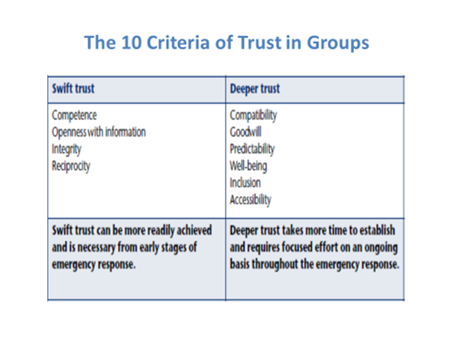  - Research has identified 10 behaviours, or criteria, that can either build or destroy trust within an emergency-response team, and they provide the basis for measuring and managing trust within a team. Using a flip chart and stick-on cards, illustrate the following:  - These ten criteria for trust can be used to provide a working definition of trust relevant in emergency-response situations. They can then be divided into two categories:  - swift trust  - deeper trust  - Your ‘trust account’ as a team member is made up of deposits and withdrawals (use the analogy of a set of scales that can be tipped in either direction).  - Unfortunately, research and experience suggest it is much easier to make a withdrawal (i.e. an action that reduces people’s trust in you) than a deposit (i.e. an action that increases others’ trust in you).  - Ask the group: what actions and communications will help to create a positive trust account with colleagues and partners in the IMST context? What actions and communications will undermine this?
2-Developing Skills for Active Listening, Non-Verbal Communication & Making Helpful Suggestions  (20 min) | Plenary Discussion | As a framework for this section of the session, the trainer places three large cards on the wall or flip chart. Each card represents a core communication skill:  - Active listening / questioning  - Non-verbal communication  - Making clear requests & helpful suggestions  - Active listening / questioning: The way that a question is asked can greatly affect the mood of the interaction and the direction of the dialogue.  Questions can be used to:  - Help determine what participants already know or think, allowing the facilitator to focus activities on gaps or outstanding issues  - Evaluate group progress and understanding  - Act as a springboard for further discussion  - Attract attention and encourage participation  - An open-ended question is used to open a discussion and cannot be answered with “yes” or “no”. Asking “open-ended” questions encourages an analytical review of the situation, and fosters a non-threatening discussion with more detailed information. Open-ended questions that begin with the words what, where, how, who, and when are likely to be very useful in clarifying the speaker’s intent;  Ask participants for questions to avoid in the interests of establishing effective communication:  - The least effective question a team member can ask is “Do you understand?” This question, as well as other yes/no questions, will often be answered with nonproductive head nods.  - Unanswerable questions—Be sure that the questions you ask can be answered by the group or by some member of the group.  - Vague, indefinite, or ambiguous questions—To get satisfactory answers you must ask good questions. Sometimes you may need to rephrase your question or break it down into sub-questions if not immediately understood.  - Witness box interrogation—You may have to ask a colleague several questions in the interest of clarification, but your conduct should never be that of a courtroom cross-examination where the person answering feels threatened. Underline that “why” questions in the past tense, if addressed at a person’s behaviour, will likely lead to defensiveness.  Discuss techniques (do’s and don’ts) for demonstrating active listening as a method for understanding underlying interests and building rapport with other IMST colleagues or, indeed, external partners. The key point is to reflect whether you are really listening in a dialogue, or simply awaiting your turn to speak (this is easily recognisable in others by the pause between speakers).  Cover the three levels for clarifying understanding; ask participants for suggestions of the meaning of each level, and the subtle differences each can have in terms of an effect on the communication space:  - Repeat  - Paraphrase  - Reframe  - Non-verbal communication: Trainer should replace slide images with photos taken of participants in similar postures throughout the week. Show how each photo on screen and ask participants what message is being conveyed by the body language. Does each posture increase or decrease the chances of effective communication?  - Eye contact and eye level;  - Angling of upper body;  - Barriers and closed off body positioning;  - Evaluative postures;  - Hand positioning;  - Touching and personal space;  - Taking notes when others speak.  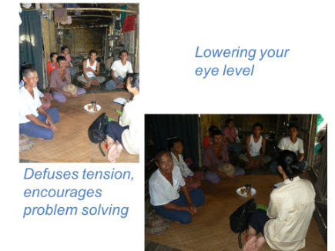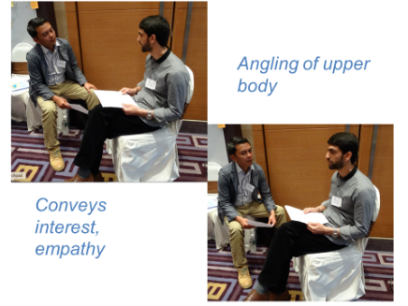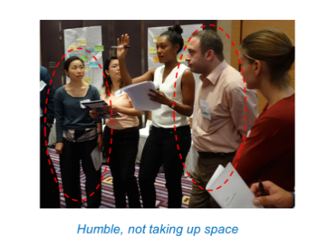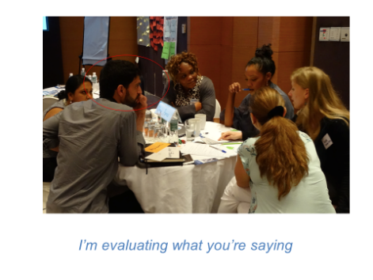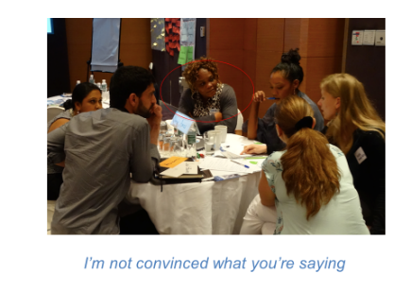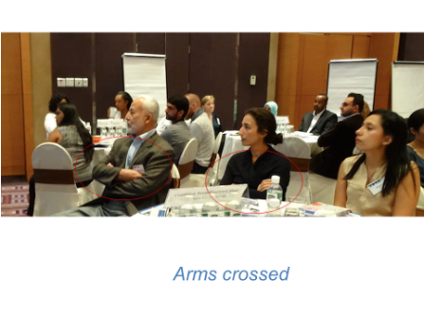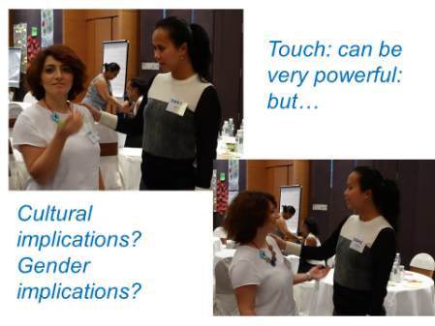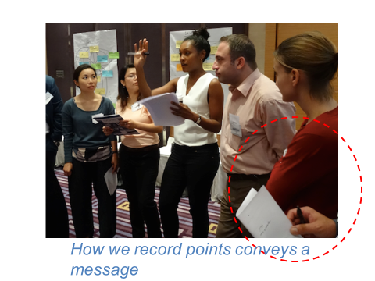  Trainer should draw on relevant findings from research, where appropriate.  Emphasize that awareness of non-verbal behaviour (our own and others) can be a useful tool, but at the same time it’s important not to become overly self-analytical.  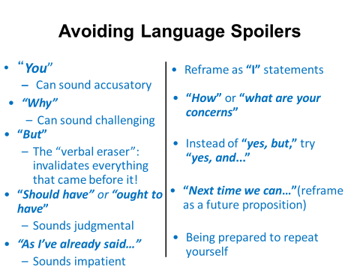  - Making clear requests & helpful suggestions: When it’s our turn to speak, the language we use can either shrink or expand the dialogue space; it can create resistance to our ideas as much as it can convey the intended message. On a flip chart or screen, show the left-hand side of the following list:  For each “spoiler” on the left of the slide, provide concrete examples relevant to the IMST context and ask them for ideas how to reframe the language used so that their message will be heard better – then reveal the right side of the chart/screen and discuss practical applications relevant to their experience.  Challenge participants to observe each other’s language for the rest of the training, and to commit to peer feedback to help continue development (e.g. during the SIMEX).
3-Dealing with Communication Challenges (lack of time, stressful environment, in conflict with a decision from the IM)  (45 min) | Group Communications Task & Debrief | Participants are broken into small table groups in the same plenary room.  Each group is allocated a facilitator who presents a series of practical dilemmas, or mini scenarios, relating to communications challenges that typically occur in IMST settings.  Note: It is not always necessary to cover all the dilemmas, the faculty team will need to prioritize according to the priorities and participant gaps. It is, however, advisable to ensure a good mix that apply to the IMST context. The faculty may also find it helpful to discuss possible solutions internally in advance, and perhaps draft some facilitator notes.  As each dilemma is read aloud or shown on printed sheets, the group is then asked to discuss the following (these prompts may be written on a chart at the front of the room, for consistency):  A. What are the communication challenges in this situation?  B. What are the options for resolving this dilemma?  C. Which option would you choose, and why?  Thereafter, group facilitators can moderate and steer their group’s discussion on to the above question prompts. Where necessary, facilitators may also guide their group to the relevant guidance document or reference material.  After each dilemma has been discussed, a plenary wrap-up may take place to clarify the key points and emphasize where further resources are available. In some instances, the recommended option may not be clear cut – in which case, a healthy debate is an acceptable end point in itself.  The session timekeeper should draw a halt to the discussion, and each sub-group facilitator continues to the next dilemma.
Summary  (3 min) | Presentation | Trainer concludes the session, linking to the other topics coming up on the agenda and setting the scene for the SIMEX later in the week.  Take any questions and answers from the group.

Annex D: Training Review/Feedback Template

Name of Presenter: _________________________ Session title: ______________________
 | Need to Improve= 1 | Competent =  2 | This was a standout = 3
Room/equipment set up was appropriate for session
Introduction of session and objectives were outlined
Key points in body of session were clearly explained
Demonstration, examples, illustrations of key points were appropriate
Timing and instructions of the learning activity were given and maintained
Adequate support was provided to learners
Open-ended questions were used to assess understanding
Feedback was given to individual learners
Conclusion of session was clear wrap up
Learning resources were useful and user-friendly and appropriate to group

Individual Facilitation skills | 1 | 2 | 3 | Individual Facilitation skills | 1 | 2 | 3
Strong and clear voice |  |  |  | Built rapport with participants
Eye contact with participants |  |  |  | Appropriate vocabulary
Awareness of body language |  |  |  | Well organised use of notes
Effective use of training room |  |  |  | Appropriate use of equipment
General comments which would assist the presenter in future

Annex E: Trainer/facilitator Self Review Template

Self-review following presentation
Complete a self-review, using the template below. Each box provides some points to consider in your reflection. Tick each box once as appropriate and write at least one comment for every criterion. The session summary box must be completed. Keep this for your records and consider carefully how your reflections might match or not the reflections of those from a peer review.
This is an excellent tool to use in a simple review of your session plan even before you present the material.

Criteria | Y | N | Criteria Comments  (at least one comment per bullet point)
Application of learning principles
- I provided a variety of learning activities
- Learners were actively involved
- I made the material meaningful and relevant
Training objective:
- Was my objective SMART?
- I considered A.S.K.?
- Reflected the training need?
Questioning:
- Used different types of questions
- Sought feedback
- Responded to questions appropriately
Session plan:
- Introduction (attention, motivation, structure)
- WHS was considered?
- WIIFM (Hook/What’s in It for Me?_
- Body (step by step, check for understanding)
- Conclusion (relate to objectives, re-cap, next session)
- Written format is easy to read and deliver
Training method:
- Involved all participants
- Appropriate for the topic
- Use of Show/tell/Do
- Support materials reinforced topic
- Developed a rapport with the audience
Use of learning aids:
- Learning aids used to accommodate different learning styles
- Learning aids used effectively
- VARK?
Clarity of expression:
- RSVP (Rhythm, Speed, Volume and Pitch) were appropriate?
- Appropriate eye contact
- Appropriate vocabulary used
Non-verbal:
- Appropriately dressed
- Body language/gestures reinforced content
- Effective use of training room
SESSION SUMMARY: What were my strengths and weaknesses? (must be completed)

Strengths:

Weaknesses:

Opportunities:

Annex F: Competency Assessment Template

COMPETENCY EVALUATION TABLE
 | PARTICIPANT 1 | PARTICIPANT 2 | PARTICIPANT 3
Competency: TEAM WORK | 59% | 74% | 30%
Behavior 1 | 2 | 2 | 1
Behavior 2 | 2 | 3 | 1
Behavior 3 | 1 | 1 | 0
Skill 1 | 1 | 3 | 0
Skill 2 | 2 | 3 | 1
Skill 3 | 3 | 3 | 1
Experience 1 | 2 | 1 | 1
Experience 2 | 2 | 2 | 2
Experience 3 | 1 | 2 | 1
INPUT BY EVALUATOR
INPUT 3 If expected behavior/skill/experience fully demonstrated
INPUT 2 If expected behavior/skill/experience partially demonstrated
INPUT 1 If expected behavior/skill/experience not Observed
INPUT 0 If opposite of expected behavior/skill/experience Observed
RESULTS
Tier 3 Competency score > 2 | More than | 67%
Tier 2 Competency score > 1 <2 | More than | 33%
Tier 1 Competency score <1 | Less than | 33%

WHE OSL TRAINING DEVELOPMENT TOOLKIT
FOR INTERNAL USE ONLY

DECEMBER 2019

Designing Instruments for Competency measurement can be a bit of an art form. You should contact your Supporting Master Trainer for help with this on a course by course basis.

